How to make a vehicle autonomous

Various levels of autonomy have been defined by SAE International (Society of Automotive Engineers). Ranging from level 0 which are our daily-use utility vehicles, until level 5 which are vehicles where no human interaction is required. Currently, we are far from a level 5 automation since there are many situations in which autonomous vehicles are not good dealing with.

First, let’s imagine we have a car and we wish to make our car autonomous. There are three main elements this car will need to become self-driving, namely, HDMap (High Definition Map); State and geolocation estimator; and a motion manager. Before we jumped into addressing these key aspects of autonomous vehicles there are a few background concepts that we need to address, such as the sensors used in autonomous vehicles.

## Sensors used in Autonomous Vehicles:

The following are some sensors used in Autonomous Vehicles :

LIDAR: Stands for Light Detection and Ranging, is a remote sensing method that uses light in the form of a pulsed laser to measure ranges (variable distances) to the Earth. This technology is used to scan roads and buildings. With a LIDAR scan, we generate a cloud point (literally a dataset of points) which can be loaded and used to represent the real world.

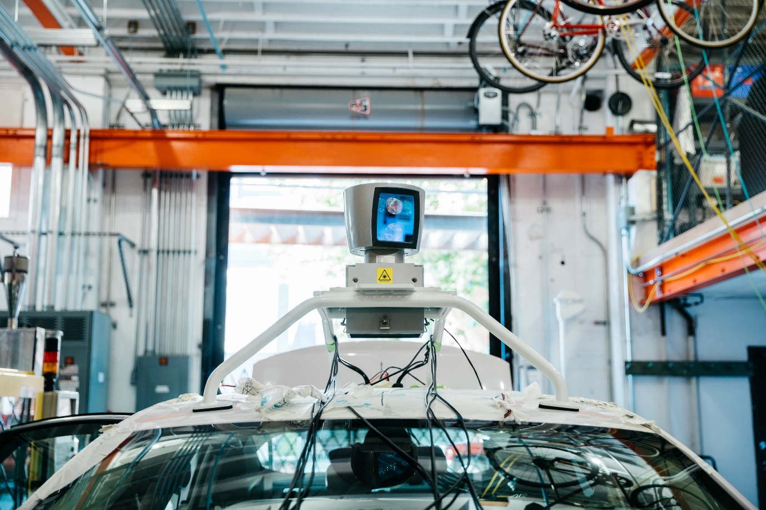

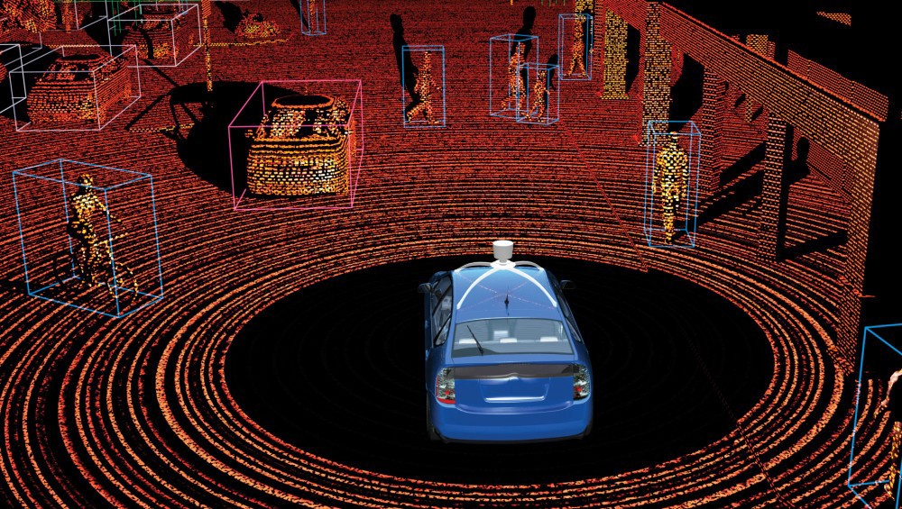

Radar: Is a detection system that uses [radio waves](https://en.wikipedia.org/wiki/Radio_wave) to determine the range, angle, or velocity of objects. Radars are one of the simplest sensors we can have in an autonomous vehicle, the distance they reach is short but they are relatively cheap when compare to LIDAR. Currently, many vehicles already use Radar technology for collision prevention during parking.

GPS: When you use your smartphone you might need to geolocate yourself in the planet; you activate your GPS. The **Global Positioning System** (**GPS**), is a satellite-based radio navigation system owned by the United States government and operated by the United States Air Force. It is a global navigation satellite system (GNSS) that provides geolocation and time information to a GPS receiver anywhere on or near the Earth where there is an unobstructed line of sight to four or more GPS satellites.

Camera: A camera is an important sensor in autonomous vehicles. It allows them to identify objects and people in the real world. This is all thanks to the advances in Computer-vision that have occurred in the latest years. Thanks to the latest development in Machine learning techniques, particularly in convolutional neural networks, Autonomous vehicles can use Cameras for object detection and object identification.

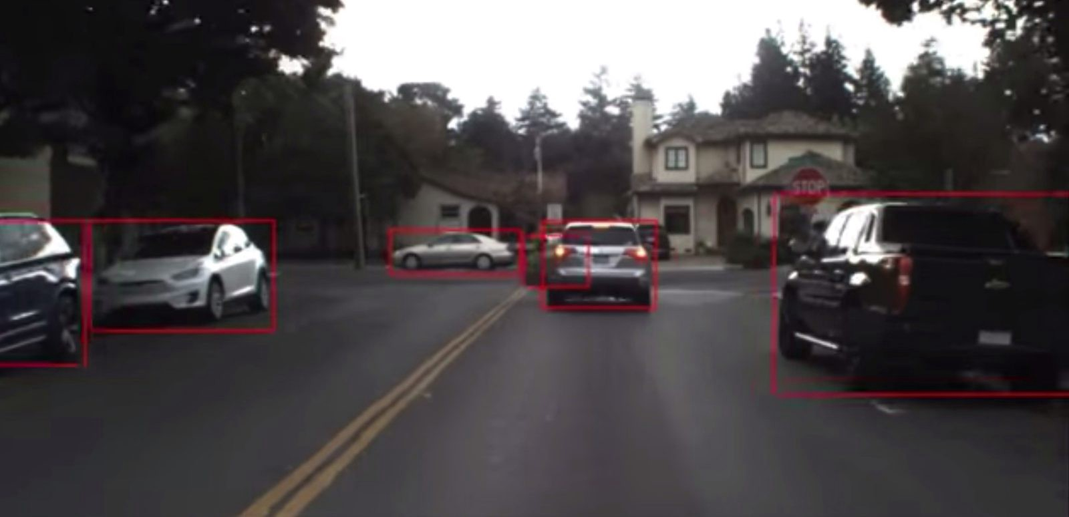

## 1st Key aspect: HDMap (High Definition Map)

The very first thing the car needs is to be able to detect its location in the world. For doing this an Automated Vehicle needs to have an HDMap (High Definition Map) which includes a lot of data about the road and the surroundings. Building an HDMap requires a lot of effort. There are companies whose only purposes is to create and keep HDMaps up-to-date.

LIDAR scans for the road surface, computer vision analysis to extract road signalization and creation of lane objects. These and more steps are required when creating an HDMap. Autonomous vehicles must always know in which lane they are located and the route must include all the necessary lane changes.

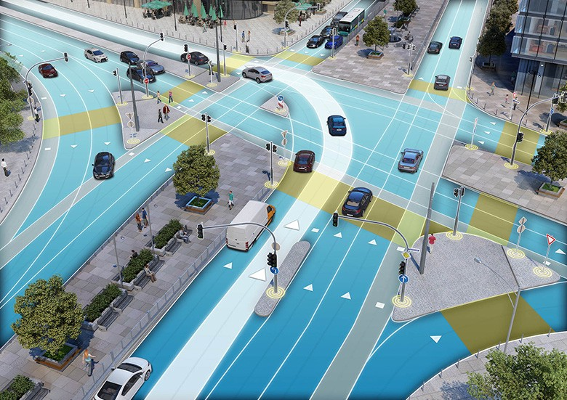

## 2nd Key aspect: State estimator

Secondly, the car needs a state estimator. The state estimator will coordinate the input from all the sensors in the autonomous vehicle and create and keep the geolocation of the vehicle within the HDMap up-to-date. It will receive input from all sorts of different parts of the vehicle.

Different situations might favor different sensors. For example, if the vehicle is inside a building the GPS signal might not be reliable and the state estimator might have to rely on other sensors such as lidar, radar and the motion of the tires to update the geolocation of the vehicle. At the same time, in a highway a truck might be in front of the vehicle blocking the LIDAR sensor from perceiving the whole world ahead of the vehicle. In this situation, our self-driving car will be blind. But with a reliable HDMap and GPS signal, our vehicle can have a very good idea of what is ahead of it.

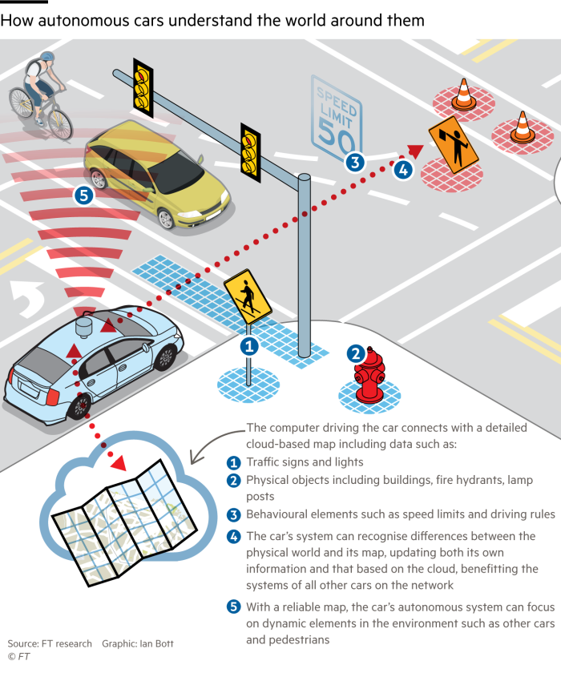

Ultimately, a state estimator will receive and combine data from multiple sensors within the autonomous vehicle. Not all sensors send data at the same rate. A LIDAR system can provide many pulsations per millisecond, while GPS takes longer to update. The state estimator is supposed to harmonize this information.

## 3rd Key aspect: Motion planner

The motion planner is the part of the autonomous vehicle in charge of the movement. If we were intending to move a self-driving car from point A to B the first option might be going forward (or reverse, or turning). The motion planner is in charge of determining which maneuvers are required for the vehicle to reach its destination. From the state estimator, the vehicle can know when an obstacle is in obstructing the vehicle’s route, then the motion planner should call for an emergency stop. When it is time for the vehicle to change lanes, the motion planner will call a maneuver for changing lanes. A motion planner is a large algorithmic dataset which acts based on the vehicle’s route.

## Conclusions

There are many more classes and algorithms to consider in the development of an Autonomous Vehicle, hopefully, this article pointed you in the right direction.